Directions: Record the number of minutes spent daily on each level of the pyramid. Then chart the number of minutes of activity below.
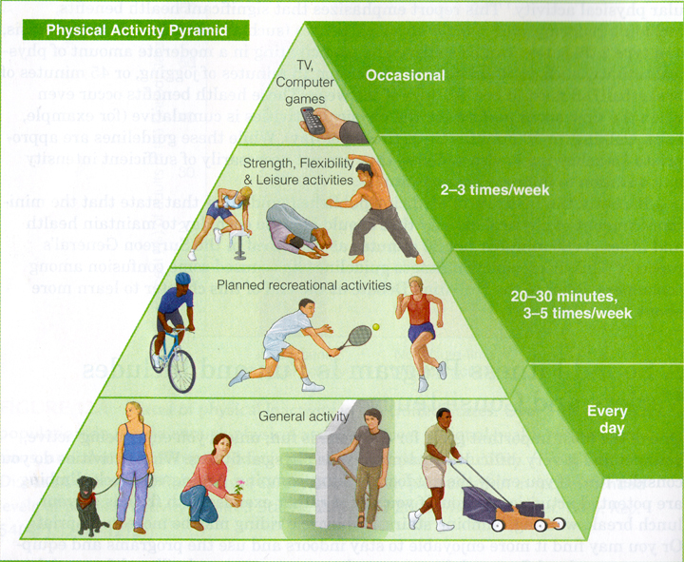
Sun | Mon | Tues | Wed | Thur | Fri | Sat
Everyday Physical Activity Minutes
Sun | Mon | Tues | Wed | Thur | Fri | Sat
Recreation Activity Minutes
Sun | Mon | Tues | Wed | Thur | Fri | Sat
Strength, Flexibility, Leisure Activity Minutes
Sun | Mon | Tues | Wed | Thur | Fri | Sat
TV and Computer Games Non-Activity Minutes
Directions: Chart the daily activity minutes by “Coloring in” or place an “X” in one square for every 10 minutes of physical activity for each day of the week.
Weekday | 10 min | 10 min | 10 min | 10 min | 10 min | 10 min | 10 min | 10 min | 10 min
Sunday
Monday
Tuesday
Wednesday
Thursday
Friday
Saturday

